**Ansible Exercise Notes**

**Day 3:**

1. Roles – single url testing

<https://medium.com/cloudnloud/roles-in-ansible-playbook-ffbe4574641b>

1. Modules
   1. Pattern: ansible db* -m ping -i inventory.ini

ansible web* -m ping -i inventory.ini

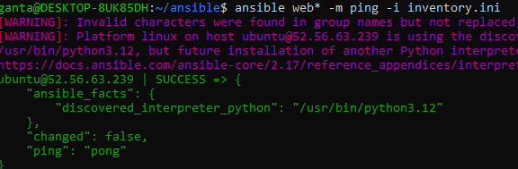

1. Ansible Playbooks – Install apache

---

- hosts: all

become: true

tasks:

- name: Install apache httpd

ansible.builtin.apt:

name: apache2

state: present

update_cache: yes

- name: Copy file with owner and permissions

ansible.builtin.copy:

src: index.html

dest: /var/www/html

owner: root

group: root

mode: '0644'

Results

